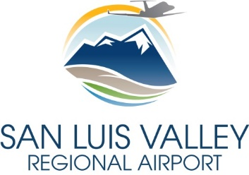

Request for Qualifications: Airport Master Plan Study
San Luis Valley Regional Airport
Q&A’s
Updated: May 16, 2019

- Can I have access to your current CIP?
The Full CIP has been uploaded to:
https://www.sanluisvalleyairport.org/doingbusinessdocuments.
- Will Exhibit A, “Airport Property Map” be included and updated in the Master Plan Study?
Yes.
- How should the sections of the SOQ be organized? Based on the Submittal Requirements (page 3) or the Selection Process and Criteria (page 4)?
This is totally up to the consultant, and makes no difference. As long as all of the criteria are addressed in the Submittal Requirements and Selection Criteria sections, the requirement would be satisfied.
- What kind of community involvement process do you wish to incorporate into this Master Plan Study?
The details and methods of the public involvement process have not fully been determined yet.
- Is there a standard contract that we would be asked to sign if selected?
The Airport does not have a standard contract form for this project, but likely we would have the successful entity provide us their standard contract and would work it from there.

